Electronic Leak Detection (ELD) and TREMproof 250GC R
__________________________________________________________________________________________
Purpose
The purpose of this bulletin is to define the equipment required to successfully test Tremco’s TREMproof 250GC R for breaches prior to protecting and placing any subsequent overburden materials.

__________________________________________________________________________________________
Introduction
Electronic Leak Detection (ELD) applies an electrical current to the surface of an exposed membrane. Figure 1. The equipment will alarm if an electrical current flows through a void in the membrane and makes contact with an electrically grounded substrate, such as structural concrete. In new construction, if the substrate is non-conductive, (for instance, wood, lightweight insulating concrete, insulation or cover board) then a conductive medium such as a conductive primer must be placed directly below the membrane to enable ELD testing.

There are four Electronic Leak Detection (ELD) methods:
- Low Voltage Scanning Platform.
- Low Voltage Electronic Field Vector Mapping.
- Low Voltage Vertical Roller
- High Voltage Spark/Holiday Testing

__________________________________________________________________________________________
Testing
The Electronic Leak Detection (ELD) method that Tremco recommends to test TREMproof 250GC R is the Low Voltage Scanning Platform. Tremco’s TREMproof 250GC R contains carbon black which is conductive and can not be tested using the vector mapping or high voltage ELD methods. Detec Systems, an electrical engineering company that produces ELD testing equipment and performs ELD testing has created the Integriscan™ low voltage scanning platform which has the capability of testing both non-conductive and semi-conductive membranes (ASTM D8231-19). Figure 2. Tremco recommends the use of the Integriscan™ low voltage scanning platform or equivalent when ELD testing is required on the job site for TREMproof 250GC R applications. Contact Detec Systems for equipment and/or services at 855.753.3832 or info@detecsystems.com.
__________________________________________________________________________________________
Figure 1

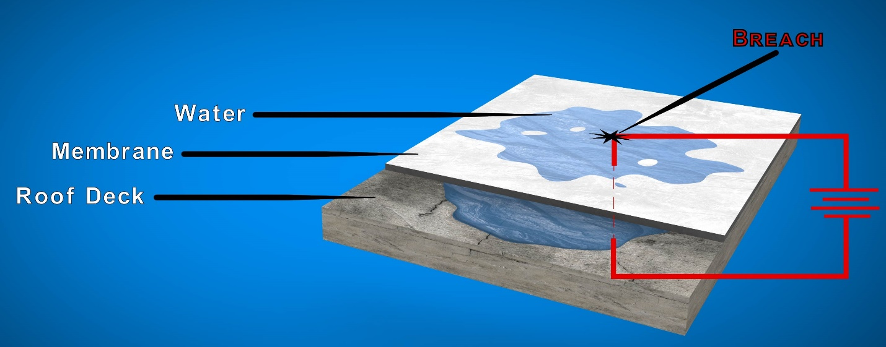

Figure 2

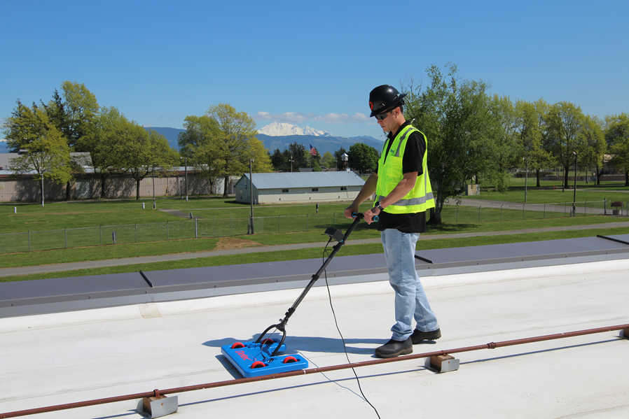

Tremco Commercial Sealants & Waterproofing | tremcosealants.com |  |  |  | MoYr/DOCCODE
3735 Green Rd  Beachwood OH 44122  216.292.5000 / 800.321.7906 | 1451 Jacobson Ave  Ashland OH 44805  419.289.2050 / 800.321.6357 | 220 Wicksteed Ave  Toronto ON M4H1G7  416.421.3300 / 800.363.3213 | 1350 Gay-Lussac, Unit: 3 Boucherville QC J4B 7G4  514.521.9555

